Blob storage
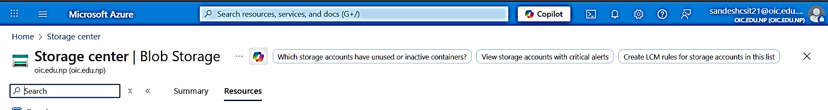
Create storage account with preferred settings:
- Stoarge account type: sandeshcsit
- Preferred storage type: Azure Blob Storage or Azure Data Lake Storage Gen2
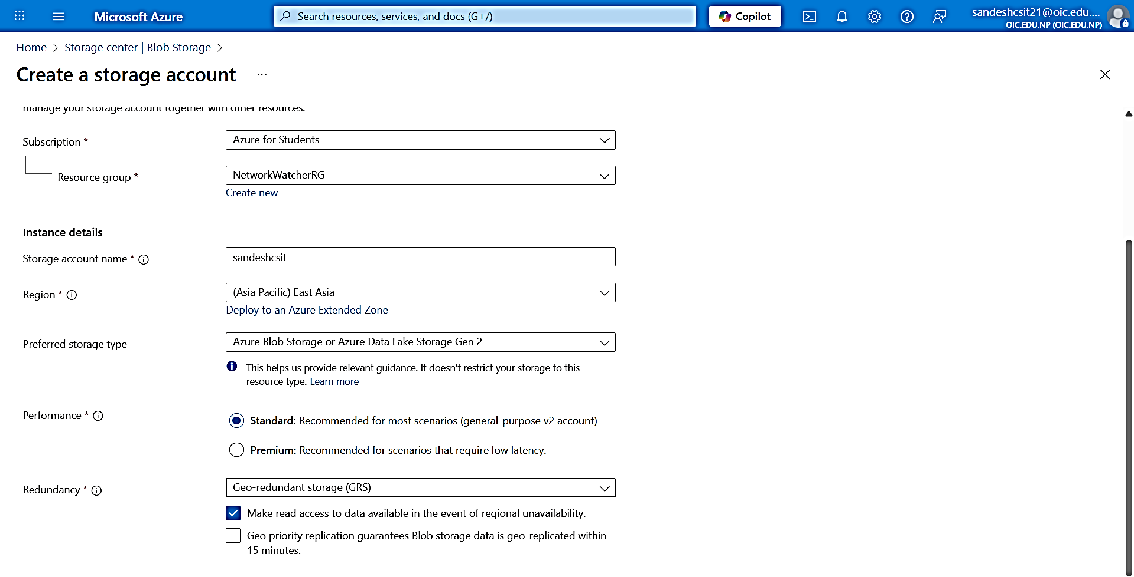
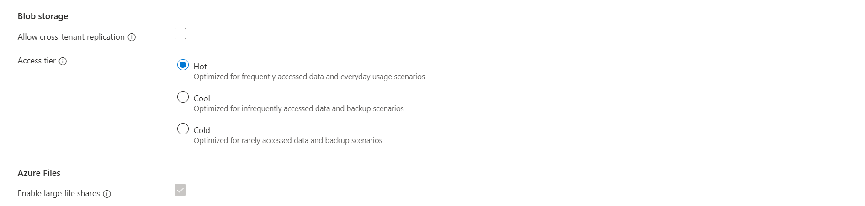
Deploy:
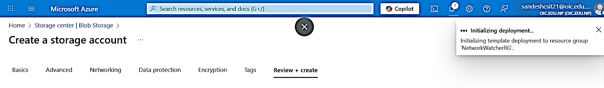

Storage account > data management > static webite
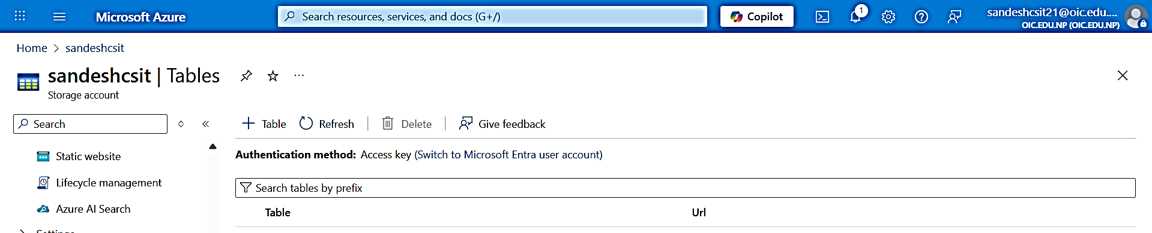

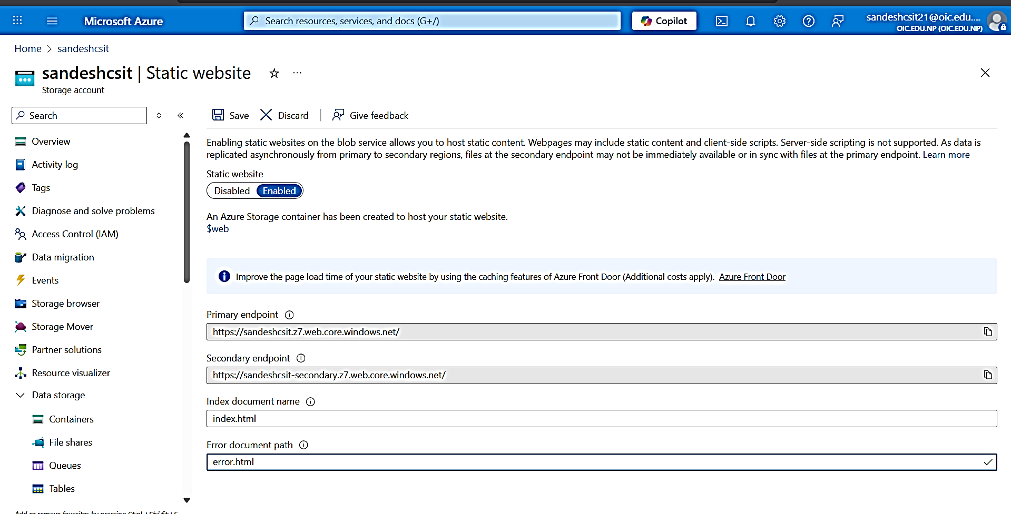

Save the
- Static website under storage > enable
- Upload file in html
- url is provided
Saved static website:
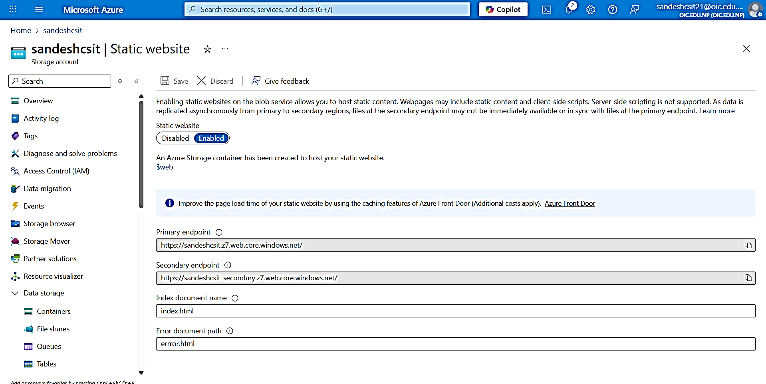
Data Storage > Container:
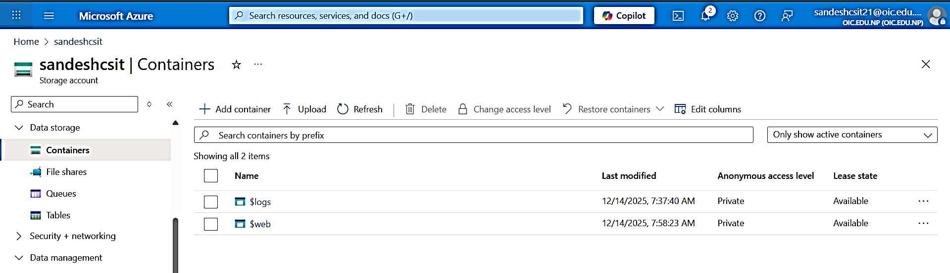
Upload file:
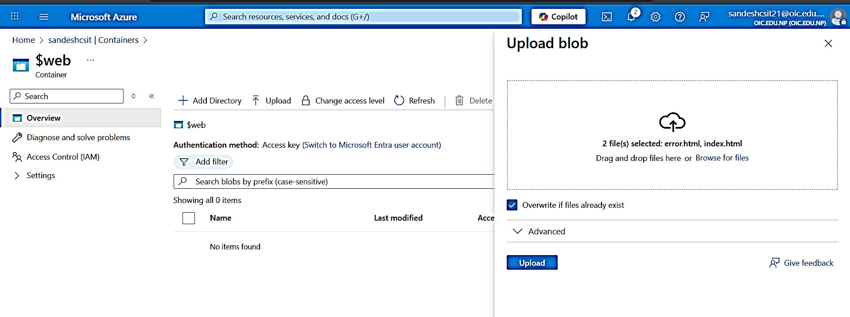
Endpoint (index.html):
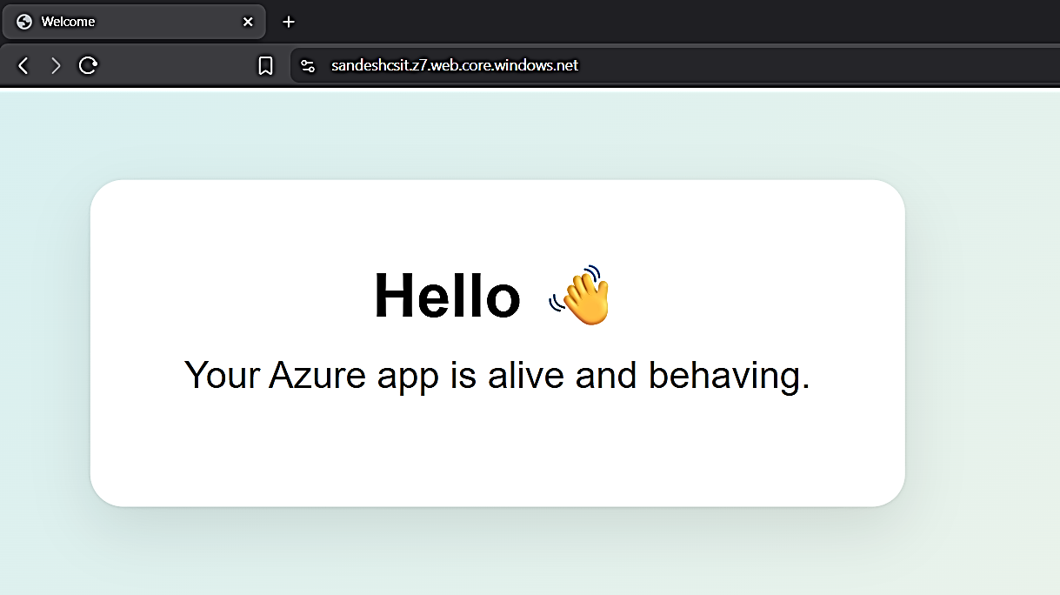

Endpoint (Error.html):
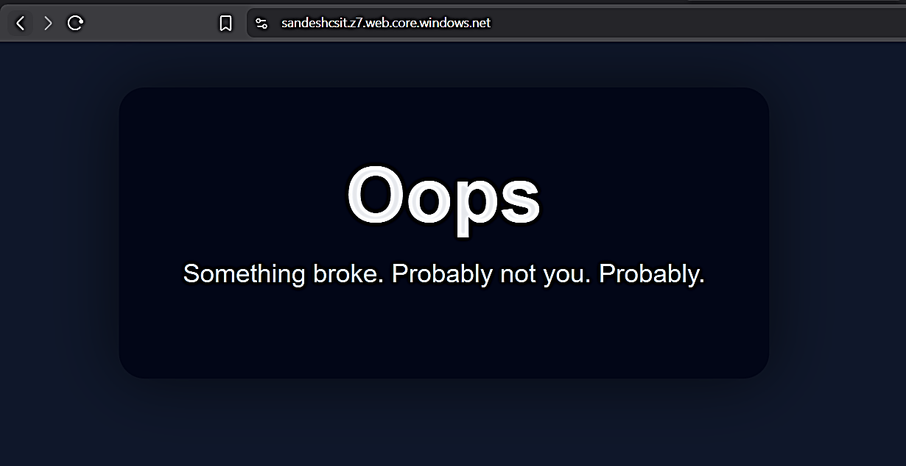

Change storage account to public:
Setting > Configuraiton > Allow Blob anonymous access
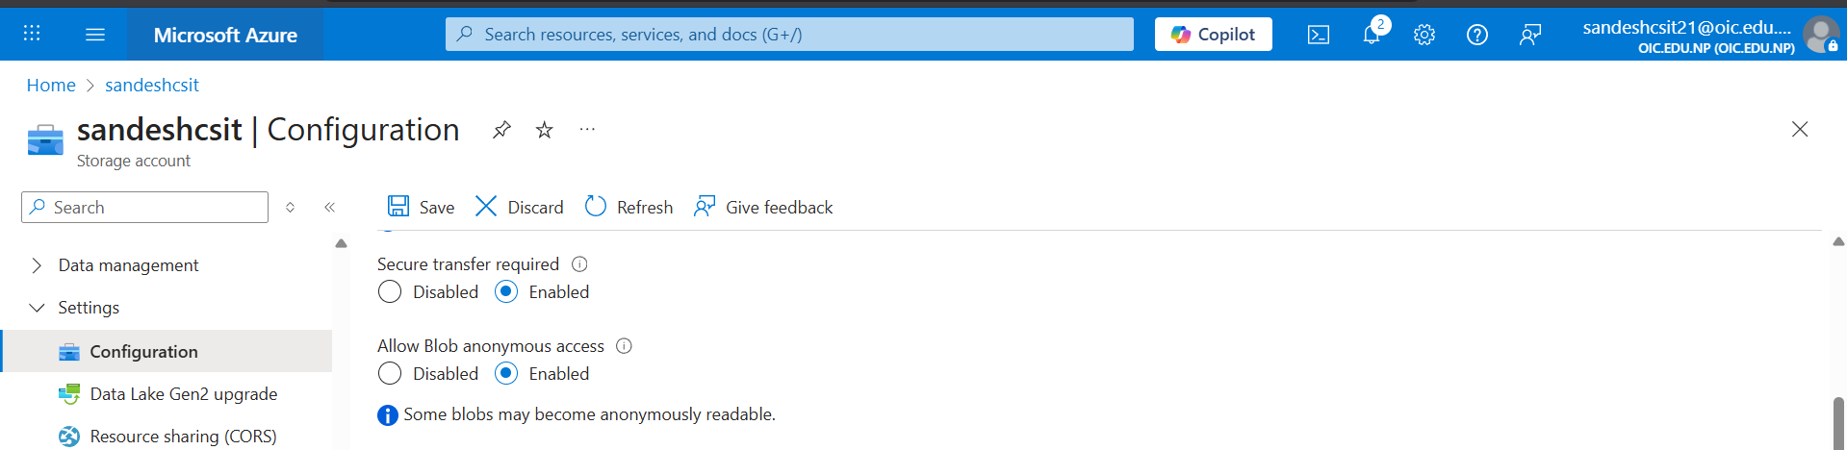

Create new container:
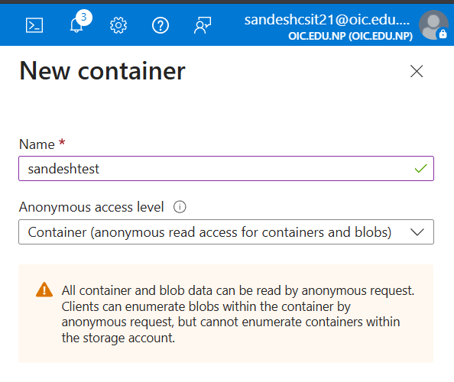
Upload content:
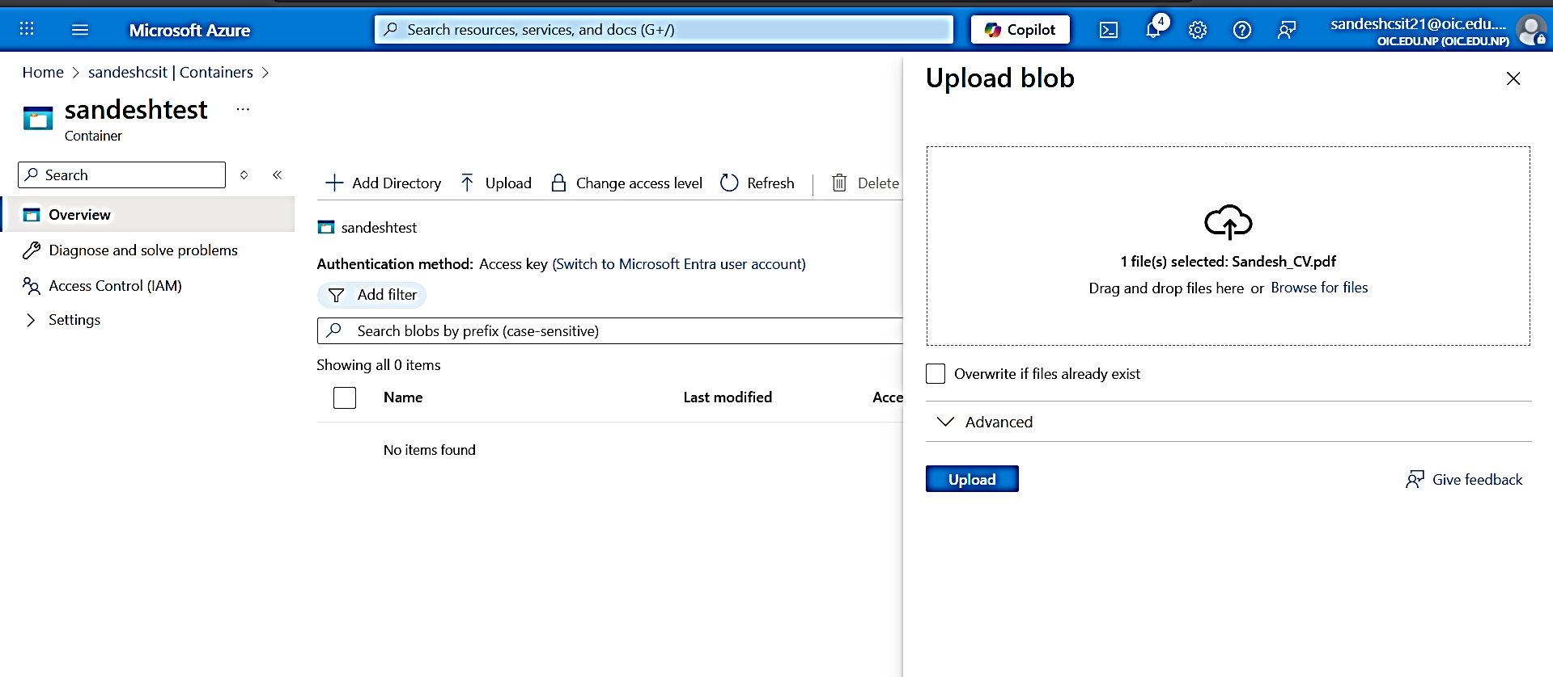

Uploaded file:
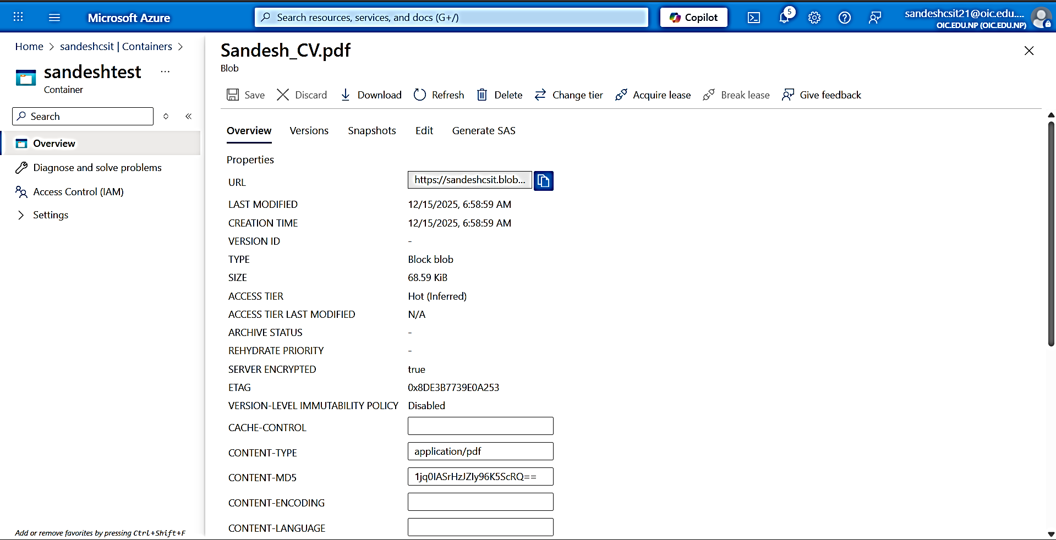

Accessing the url:
